Wednesday & Thursday

May 15 & 16, 2019

Apotex Centre, Bannatyne Campus

Winnipeg, Manitoba

**FACULTY**

**Teaching Improvement Program (TIPs)**

Anita Ens

Joanne Hamilton Laura MacDonald Helen Mawdsley

Margaret Morris Jason Peeler Christen Rachul Ingrid Toews Mark Torchia

Tanya Walsh

Pam Wener

Steve Yurkiw

The Teaching Improvement Program (TIPs) is an intensive two-day workshop which includes presentations, discussions and individual work. The workshop content is grounded in educational theory which is applicable across all disciplines and specializations. A practical and focused approach is taken to incorporate theory into practice so that participants complete the workshop with knowledge and skills they can apply in their teaching roles. Workshop objectives are achieved through the experience of defining learning objectives and planning a condensed instructional session known as a ‘microteach’.

**HISTORY**

This workshop is based on the Teaching Improvement Project System developed by the Centre for Learning Resources, College of Allied Health Professionals, University of Kentucky, through grants from the WK Kellogg Foundation. Since its inception in 1975, this program has reached thousands of educators in Canada and the United States. The University of Manitoba became a program site in 1993. Modifications

and updates to the original program were completed at the University of

Manitoba in 1999 and 2012.



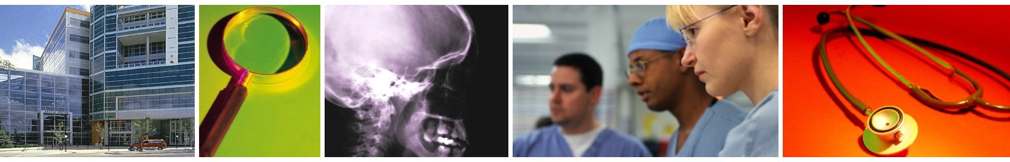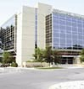

**TIPs – May 15 & 16, 2019 — Bannatyne Campus**

**COURSE OBJECTIVES**

Following completion of this course, the participants will be able to

▪ plan and organize an instructional session

in any setting,

▪ formulate instructional objectives appropriate to their own setting,

▪ apply presentation techniques in their own setting,

▪ formulate questions that promote thinking,

▪ use methods that help students become active participants, and

▪ evaluate their teaching behaviours.

**AGENDA**

Day 1 – Wednesday, May 15, 2019

8:30 a.m. – 4:30 p.m.

Day 2 – Thursday, May 16, 2019

8:30 a.m. – 4:30 p.m.

**REGISTRATION**

Full Fee: $450.00

Includes all course materials, continental breakfast and lunch on both days.

To register click [here](https://www.cpd-umanitoba.com/events/faculty-teaching-improvement-programs-tips-may-15-and-16-2019/). Please contact Karen DePape in the Office of Educational & Faculty Development [Karen.depape@umanitoba.ca](mailto:Karen.depape@umanitoba.ca) / (204) 272-3102 if you need assistance with your registration.

**REFUND POLICY**

All course cancellations received in writing prior to May 8 will be refunded in full (minus a $50 administration fee). Cancellations received between May 10-14 will be refunded at 50%. No refund will be given after the course begins on May 15.

**ACCREDITATION**

This event was co-developed with the CPD Medicine Program, University of Manitoba and was planned to achieve scientific integrity, objectivity and balance.

This one-credit-per-hour Group Learning program meets the certification criteria of The College of Family Physicians of Canada and has been approved by the CPD Medicine Program, University of Manitoba for up to 13.5 Mainpro-M1 credits.

This event is an Accredited Group Learning Activity (Section 1) as defined by the Maintenance of Certification Program of The Royal College of Physicians and Surgeons of Canada, and approved by the CPD Medicine Program, University of Manitoba for a maximum of 13.5 hours.

Participants should only claim credit for the actual number of hours attended.

The University of Manitoba CPD Medicine Program is fully accredited by the Committee on Accreditation of Continuing Medical Education (CACME).

**CONTACT INFORMATION**

Office of Educational & Faculty Development

Rady Faculty of Health Sciences

University of Manitoba

S204 Medical Services Building

750 Bannatyne Avenue

Winnipeg, Manitoba R3E 0W2

Ph: (204) 272-3102 Fax: (204) 272-3169