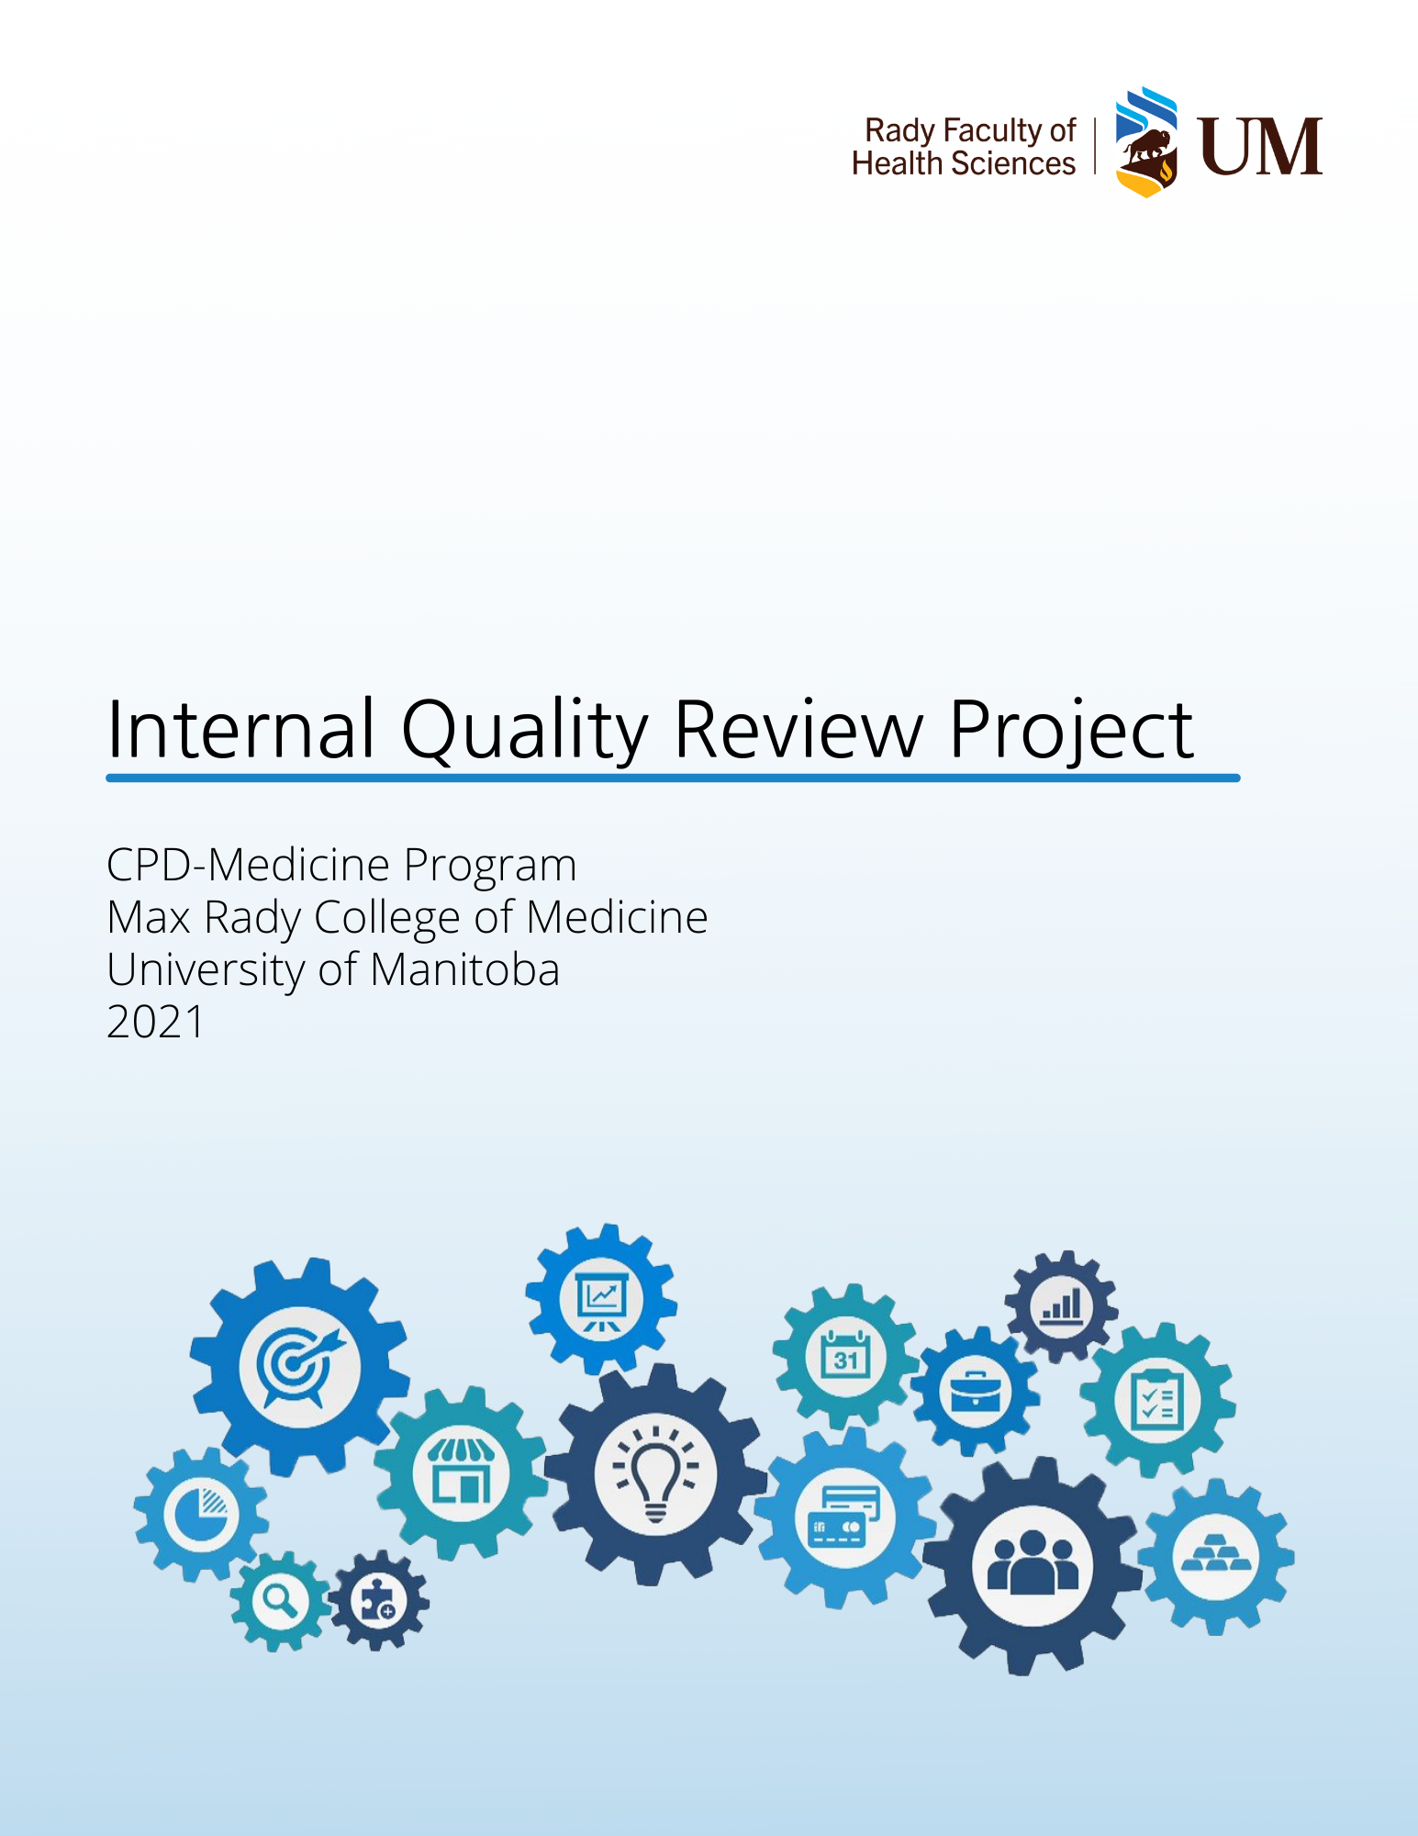

# Document Information

This document is a dynamic document. To ensure access to the most recent version, please contact:

* Christine Polimeni MD, CCFP, FCFP

Associate Dean, Office of Continuing Competency and Assessment

[christine.polimeni@umanitoba.ca](mailto:christine.polimeni@umanitoba.ca)

* Helen Mawdsley, EdD

Director or Research, Office of Continuing Competency and Assessment

[helen.mawdsley@umanitoba.ca](mailto:helen.mawdsley@umanitoba.ca)

* Jeff Toews, MEd

Director or Educational Development, CPD Medicine Program

[jeff.toews@umanitoba.ca](mailto:jeff.toews@umanitoba.ca)

This document is intended to be read in conjunction with:

* CACME Accreditation Documentation (available at: <https://cacme-caemc.ca>)

Table of Contents

Document Information 2

Background and Purpose 5

Description of the IQR Project 5

The CPD Medicine Program 5

IQR Project Scope 7

IQR Project Goals 8

IQR Project Timelines 8

IQR Project Contributors 9

Diversity & Inclusion Facilitator 10

University of Manitoba 10

Director of Integrated Accreditation Unit 10

Structure of the IQR Project 10

PLAN Section of PDSA 10

DO Section of PDSA 12

STUDY Section of PDSA 13

ACT Section of PDSA 18

Gap #1: Curriculum Mapping Tool Inconsistently Used. 18

Gap #2: Absence of EDI content in Learning Objectives 18

Gap #3: Processes need to be formalized 19

Recommendations for subsequent PDSA cycle 20

References 21

Appendix A – IQR Guide 22

Appendix B – External Reviewer Guide 22

Appendix C – RFHS Strategic Framework 22

Appendix D – Resources for Writing Learning Objectives 22

Appendix E – Curriculum Planning Tool (Past and Current) 22

Appendix F – Disruption of All Forms of Racism Policy 22

Appendix G – Blank Rubric (For Internal Use in the IQR Project) 23

Appendix H – Rubric for Fridays 25

Appendix I – Rubric for Skills 29

Appendix J – Rubric for OAT 33

Appendix K – Needs Assessment Data 37

Appendix L – Documents for Fridays 37

Appendix M – Documents for Skills 37

Appendix N – Documents for OAT (Brandon Jan 16-17 Session) 37

Appendix O – EDI Theories in SPCs 37

# Background and Purpose

The CACME Secretariat has requested that the Office of Continuing Professional Development’s CPD Medicine Program in the Max Rady College of Medicine, at the University of Manitoba complete an Internal Quality Review (IQR) project. The purpose of this document is to document this IQR project. See Appendix A – IQR Guide, a quick guide for conducting an Internal Quality Review, and Appendix B – External Reviewer Guide.

While the CPD Medicine Office currently holds a full accreditation status, accreditation standards are ever evolving. In addition, the local organization which houses our office has a strategic focus on equity, diversity, inclusivity, and anti-oppressive practices, as described in the RFHS Disruption of all Forms of Racism Policy (Appendix F). We are uncertain how the programming within the CPD Medicine Office demonstrates this local commitment to social accountability. We also want to ensure that we are continuing to meet Standard 2.2, so that if gaps are found, that there would be an opportunity to address them within this accreditation cycle.

# Description of the IQR Project

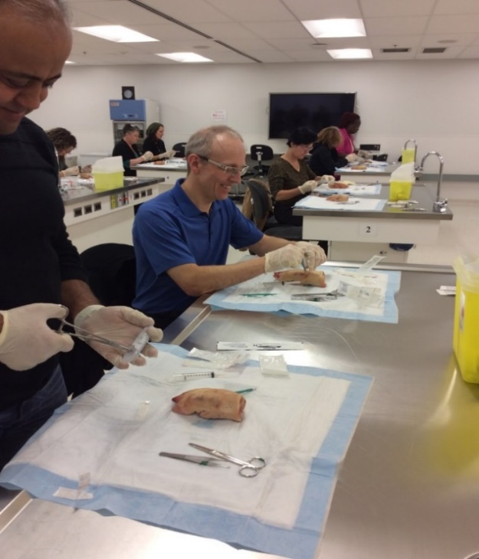This section will describe the CPD Medicine Program and the scope, goals, contributors, and timelines of the IQR Project.

The CPD Medicine Program

The CPD Medicine Program is an accredited unit that resides within the Office of Continuing Competency and Assessment (CCA). The CPD Medicine Program provides support in the development and implementation of evidence- informed educational programs that produce changes in knowledge, skills and behaviors in multiple competency domains for health care professionals. The unit’s offerings include: developed and co-developed programming for local and distributed interprofessional audiences, event management, accreditation services, self-directed learning programs, exam support, research, and faculty/learner support on topics ranging from CPD faculty development, to resources, to one-on-one coaching.

*Image Description: Dermatology Day Skills participants are practicing suturing techniques. Photo supplied courtesy of CPD Medicine Program.*

The CPD Medicine Program aligns its deliverables with the Rady Faculty of Health Sciences (RFHS) strategic framework while maintaining its mission statement:

*Serving our diverse communities, we provide evidence-informed educational opportunities to health professionals for life-long learning, competence and sustained practice change, in a culturally safe and responsive manner.*

The CPD Medicine Program mission statement also aligns with the RFHS shared set of values of: Community & Collaboration; Scholarship & Innovation; Equity & Inclusion; Professionalism; and Social Accountability (see Appendix C – RFHS Strategic Framework).

In addition, this IQR Project addresses several supporting actions from the RFHS Strategic Framework, including:

|  |  |
| --- | --- |
| **Strategic Priority** | **Supporting Action** |
| Education and the Learner Experience | * Promote a teaching and learning environment that fosters life-long learning across the education continuum, including pre-licensure/ undergraduate, postgraduate, graduate and continuing professional development programs. * Renew a focus on ensuring a respectful learning environment, with attention to physical, cultural, social and emotional safety and needs in learner wellness. |
| Indigenous Health and Achievement | * Require training in cultural proficiency, including the development and support of a respectful and culturally safe environment. |
| Teaching and the Working Environment | * Renew a focus on ensuring a respectful working environment, with attention to physical, cultural, social and emotional safety and staff needs in wellness. |
| Research | * Develop mechanisms to encourage research in areas important to social accountability. |

The mandate of the CPD Medicine Program is to support the educational and continuing professional development of health professionals along the continuum of learning. Through this continuous quality improvement process, the Program endeavors to uphold the tenants of inclusivity and thereby address barriers that may negatively impact the learner experience, with an emphasis on the diverse populations we serve. We have chosen to focus on activities, such as creating learning objectives, which are central to content development and further address multiple competencies as a key driver of integrating inclusivity into educational activities. It is within these competency roles that the learning environment may be enhanced to ensure cultural safety is integrated into education and eventually daily practice. Learning objectives that support cultural proficiency for specific populations (eg. Indigenous Health) are a priority for the CPD Medicine Program. Activities such as staff training on inclusivity, expanding our EDI resources in how to incorporate EDI into CPD activities, as well as incorporating EDI questions into our accreditation applications supports our Faculty’s renewed focus on ensuring a respectful teaching and working environment. It is through these changes that we hope to assist scientific planning committees in supporting this action and thereby creating a culture of inclusivity. Finally, the CPD Medicine Program will evaluate its programs through a lens of inclusivity and address outcomes through best practices and evidence- informed actions.

## IQR Project Scope

A number of topics could meet the requirements of this IQR project. For example, a CPD Office could elect to focus on a standard which was partially compliant, or a standard which has been newly revised, or select a standard which is commonly cited. Currently, the CPD Medicine Program is in full compliance with Committee on Accreditation of Continuing Medical Education (CACME) accreditation standards. After consultation within the CPD Medicine Program, the Dean and Vice-Provost, and representatives from the RFHS Integrated Accreditation Unit, the CPD Medicine Program has elected to select a standard which has an opportunity to embed organizational priorities in social accountabilities, as well as ensure that the CPD Medicine Program is in full compliance.

Standard 2.2 focuses on the development of learning objectives. From CACME:

*An accredited CPD provider organization develops learning objectives for each activity to address identified professional practice needs. The learning objectives for the overall activity and individual sessions (where applicable) are:*

* *written from the learner’s perspective;*
* *consistent with the chosen educational format; and*
* *provided prior to the activity for review by potential participants.*

*Compliance Targets: The CPD provider organization demonstrates how identified needs are used to create overall and session-specific learning objectives that are written from the learner’s perspective, consistent with the chosen educational format and provided prior to the activity for review by potential participants.*

The scope of the IQR project will be to focus on compliance for Standard 2.2, through a lens of social accountability as informed by the organizational strategic plan. Accreditation standards continually evolve, reflecting the complex landscape and emerging needs of CPD/CME. The IQR Project will focus on the expectations of Standard 2.2, as it was written in April 2021, when planning for this project began. In addition to meeting the requirements of compliance, the IQR project will also look for areas to improve, and areas to demonstrate excellence, which is consistent with the CPD Medicine Program’s mission statement.

To complete the requirement for the IQR Project, the CPD Office will undertake 1 PDSA cycle in which to begin an ongoing momentum of continuous quality improvement within Standard 2.2 and will provide recommendations for a subsequent PDSA cycle. While the focus is primarily on Standard 2.2, the scope of the project will touch upon other standards, as some of the standards are richly interconnected. For example, while Standard 2.2 does not explicitly address CanMEDs roles distributed across learning objectives, Standard 2.3 requires that multiple roles are distributed across content. As learning objectives structure content, we drew in from Standard 2.1 and Standard 2.3 when structuring our IQR project as we feel that these extra pieces of data will enlighten if the learning objectives are truly addressing identified practice needs from a more holistic perspective.

## IQR Project Goals

Currently, the CPD Office promotes that learning objectives (LO’s) are created for each individual session as well as each program, are written from the learner’s perspective, span a range of Bloom’s taxonomy, and address multiple CanMEDs competencies (see Appendix D – Resources for Writing Learning Objectives). However, the extent to which this intention is currently being met is unknown. Furthermore, social accountability is a priority to the organization, and learning objectives will also be assessed for EDI content.

The IQR Project has the following goals:

* Assess for full compliance in three or more different learning activities (Fridays at the University Bannatyne Campus Program, Skills Workshop, and Opioid Agonist Therapy Workshop) demonstrating how learning objectives are:
  + mapped to needs assessments
  + written from the learner’s perspective
  + consistent with educational format
  + provided to participants before the learning activity
  + distributed across CanMEDs roles
  + created at the overall program level, and session level
* Assess tools used to develop curriculum mapping strategies, including:
  + Discussion on how these tools work
  + Gather feedback for improvement on tools
  + Assess faculty development needs in utilizing tools to create curriculum mapping (determine if there is improvement needed to tool or implementation of the tool) (See Appendix E – Curriculum Planning Tool)
* Assess program materials showing overall and session specific learning objectives.
* Through a social accountability lens, assess if learning objectives demonstrate tenants of local EDI policies.

Where any of these assessments reveal deficiencies, there will be an action plan developed to address shortcomings.

## IQR Project Timelines

The expectation is that the IQR is to be conducted by the CPD office prior to December 31, 2021, with decanal sign-off submitted to the CACME Secretariat by February 1, 2022. The timelines for our project are as follows:

|  |  |  |  |  |  |
| --- | --- | --- | --- | --- | --- |
| **Plan the IQR Project** | **Complete the IQR Project** | **Submit for External Review** | **External Review Completed** | **Submit for decanal approval** | **Decanal Sign-off for submission to CACME** |
| April 2021-July 2021 | October 3, 2021 | November 9, 2021 | November 30, 2021 | December 15, 2021 | February 1, 2022 |

## IQR Project Contributors

We felt that it was prudent to ensure that we include CPD Medicine team members, who work on these standards routinely, as this will continue to develop our desire to have a culture of continuous quality improvement. In addition, involvement of this core group will facilitate implementation and uptake of any recommendations stemming from this quality improvement project.

While this project is supported broadly by the CPD Medicine Program, the Max Rady College of Medicine, and the Rady Faculty of Health Sciences, the core project team is comprised of the following people:

|  |  |  |
| --- | --- | --- |
| **Name** | **Title** | **Contribution** |
| Christine Polimeni MD, CCFP, FCFP | Associate Dean, Office of Continuing Competency and Assessment | * Established scope and content of the IQR * Established framework for the IQR * Wrote and revised parts of the IQR * Provided data for portions of the rubric * Connected with external reviewers * Provided content for the external reviewer process guide |
| Helen Mawdsley, EdD | Director or Research, Office of Continuing Competency and Assessment | * Established framework for the IQR * Wrote and revised parts of the IQR * Provided data for portions of the rubric * Provided content for the external reviewer process guide |
| Jeff Toews MEd | Director or Educational Development, CPD Medicine Program | * Wrote and revised parts of the IQR * Provided data for portions of the rubric * Provided content for the external reviewer process guide |
| Lenore Chipman | Assistant to the Associate Dean, CCA Leadership & Accreditation Specialist, CPD Medicine Program | * Provided data for portions of the rubric |
| Ana Mullen | Lead Program Coordinator, CPD Medicine Program | * Provided data for portions of the rubric |
| Valerie Schulz MD, FRCPC | Associate Dean, CPD  Schulich School of Medicine and Dentistry  University of Western Ontario | * External Reviewer |
| Valerie Williams CPHR, CCIP | Diversity & Inclusion FacilitatorUniversity of Manitoba | * External Reviewer |
| Ricardo Soriano M.A. ED | Director of Integrated Accreditation Unit | * Reviewed the IQR project document * Provided content for the external reviewer process guide |

# Structure of the IQR Project

The IQR Project will follow a Plan-Do-Study-Act (PDSA) structure. The scope of this IQR Project, is to complete 1 PDSA cycle and provide recommendations for a subsequent PDSA cycle. The PDSA cycle is an accepted approach to quality improvement in systems, particularly in systems, if implemented well (Taylor, 2014). However, even with a PDSA structure, QI projects have been criticized for lacking academic rigour and legitimacy, and usefulness (Brown et al., 2020). To address this criticism, this project will be founded on a problem of practice, as is typically found within educational research and scholarship. Stemming from the problem of practice, research questions will be derived. The responses to the research questions will involve quantitative and qualitative data sources and analysis. The scope of the problem of practice and research questions has been carefully designed so that once the responses to the research questions are provided, then responses to the questions posed by CACME in Standard 2.2 can also be answered.

## PLAN Section of PDSA

Three programs have been chosen for this IQR project from the previous academic year; Fridays at the University (known as Fridays), Skills Workshops (known as Skills), and Opioid Agonist Therapy (known as OAT, specifically the series from Brandon 16-17 Jan 2020 was chosen). We are uncertain if the CPD Office educational programming is consistently partially compliant or compliant in Standard 2.2 in the selected three programs, as these Standards have changed since the last accreditation cycle. The questions from the newly revised Accreditation Standard 2.2 are:

1. Describe the process used to create overall and session-specific learning objectives based on identified professional practice needs.
2. Describe who is responsible to ensure the learning objectives meet established standards.
3. Describe the process used to disseminate learning objectives to potential participants prior to the activity.

Questions 1 & 3 are straightforward. The CPD Medicine Program comprises of faculty and staff, who are knowledgeable in accreditation standards for developing educational programming. Team coordinators and Program faculty meet with scientific planning committee (SPC) chairs to ensure that there is a process for ensuring that needs assessments are presented to scientific planning committees for developed and co-developed programs. Learning objectives are linked to various needs assessment sources (Appendix K), evaluation data from prior events, as well as pre-event needs assessments using a variety of strategies. This is dependent on the type of educational credits sought. Although many SPC’s derive learning objectives from needs assessments organically through meeting deliberations, the Program also utilizes a curriculum tool (Appendix E) as well as pre-needs questionnaires (2/3 credit per hour CFPC certification) to further develop learning objectives for developed and co-developed programs. Educational events that are deemed external to the CPD office may only seek Royal College accreditation, and must include sources of needs assessments as well as answer questions on how the SPC derived learning objectives when completing the University of Manitoba CPD Medicine Program accreditation application. This new [online application form](https://www.cognitoforms.com/UniversityOfManitoba4/UniversityOfManitobaCPDAccreditationApplication)links to the curriculum tool to further assist external users in the process. Faculty within the CPD Medicine Program work with SPC chairs to ensure that learning objectives meet the standards for CPD Medicine Programming. Resources are available to assist with the creation of learning objectives and are available through the CPD Medicine Program website as well as offered as a point of learning link in the new online application form. Once the learning objectives have been reviewed and finalized, the CPD Medicine Program coordination staff disseminate the learning objectives on multiple platforms. This includes promotion and marketing material, the event management site landing page, as well as the event agenda, which is available to learners prior to the event (see Appendix L-M).

As stated, CPD Medicine Program Faculty are responsible to review learning objectives. However, we feel that Question 2 requires further exploration. To facilitate answering this question, we felt that we needed to elaborate further and offering reasoning on what these standards are. In addition, the research questions also expand to cover the social accountability lens and additional content to cover the CanMEDs roles. Research questions to address problem of practice:

* Are the learning objectives informed by the needs assessment results?
* Are the learning objectives written from the learner’s perspective?
* Are the learning objectives consistent with the chosen educational format?
* Are the learning objectives created for every program, and for each session within an event?
* How are the learning objectives communicated to participants prior to the learning activity?
* What is the distribution of learning objectives distributed across the CanMEDs roles?
* What is the distribution of learning objectives across different levels of learning?
* How is EDI content currently represented in learning objectives?
* Was a curriculum mapping tool used?

## DO Section of PDSA

The following data sources will be used to provide responses to the research questions:

|  |  |
| --- | --- |
| **Research Question** | **Data Source** |
| Are the learning objectives informed by the needs assessment results? | * Document review of needs assessment materials, event planning materials, and event materials. * Consultation with CPD Medicine staff. |
| Are the learning objectives written from the learner’s perspective? | * Document review of event materials. * Consultation with CPD Medicine staff. |
| Are the learning objectives consistent with the chosen educational format? | * Document review of event materials. * Consultation with CPD Medicine staff. |
| Are the learning objectives created for every program, and for each session within an event? | * Document review of event materials. * Consultation with CPD Medicine staff. |
| How are the learning objectives communicated to participants prior to the learning activity? | * Document review of event materials. * Consultation with CPD Medicine staff. |
| What is the distribution of learning objectives distributed across the CanMEDs roles? | * A database of learning objectives was created in SPSS to facilitate analysis. * Document review of event materials. * Consultation with CPD Medicine staff. |
| What is the distribution of learning objectives across different levels of learning? | * A database of learning objectives was created in SPSS to facilitate analysis of learning objectives across different learning levels. The levels were described as low, medium, or high. The event agendas provided the learning objectives. * Document review of event materials. * Consultation with CPD Medicine staff. |
| How is EDI content currently represented in LOs? | * A database of learning objectives was created in SPSS to assist with analysis of terms used in learning objectives. * Document review of event materials. * Consultation with CPD Medicine staff. |
| Was a curriculum mapping tool used? | * Document review of needs assessment materials, event planning materials, and event materials. * Consultation with CPD Medicine staff. |

A summary for each of the programs is provided in a Rubric. See the following appendices:

* Appendix G – Blank Rubric
* Appendix H – Rubric for Fridays
* Appendix I – Rubric for Skills
* Appendix J – Rubric for OAT
* Appendix K – Needs Assessment Data

See the following appendices for documents related to each event.

* Appendix L – Documents for Fridays
* Appendix M – Documents for Skills
* Appendix N – Documents for OAT (Brandon Jan 16-17 Session)

## STUDY Section of PDSA

The rubrics were applied to each of the programs, and are available in Appendices H-J. It was possible to complete all sections for all rubrics. Using the content from the rubric, a response to each research question will now be provided, and a short summary will complete this STUDY section.

**Q: Are the learning objectives informed by the needs assessment results?**

All three selected programs were found to be compliant. Specifically, for Fridays and Skills, sessions can be mapped to multiple needs assessments data sources, with many of the topics for Fridays identified through CPD Needs Assessment surveys. In addition to validating the needs expressed in this survey, there were other needs expressed by Scientific Planning Committee (SPC) members, or subject matter experts in the community. Event evaluations from previous events also provided topics to include in future programming. For OAT, the SPC uses multiple needs assessment strategies including surveys, pre workshop needs assessments on the learners, pretest results, evaluation data from previous events, and post event survey data from previous events.

**Q: Are the learning objectives written from the learner’s perspective?**

Yes. Learning objectives are written from a learner’s perspective and use actionable verbs. For Skills, the actionable learning objectives require learners to demonstrate the newly acquired skill, explain indications for procedures, and explain the best evidence are utilized.

**Q: Are the learning objectives consistent with the chosen educational format?**

Yes. For Fridays, all learning objectives are consistent with the educational format. In Skills, the educational format aligns with learning objectives in that small group sessions encourage discussions on best practices and largely focus on demonstration of the newly acquired skill. In OAT, all learning objectives are consistent with educational format of didactic learning. Simulations using standardized patients support learning objectives that focus on communication and collaboration strategies in an interprofessional health team.

**Q: Are the learning objectives created for every program, and for each session within an event?**

Yes. Each session had learning objectives, which connected to larger program-level objectives.

**Q: How are the learning objectives communicated to participants prior to the learning activity?**

The learning objectives are on the registration page, they are also on the agendas, which are emailed to participants prior to the event.

In addition to prior to the learning activity, at the learning activity, we recommend that the speakers begin their presentation with a slide showing the learning objectives as a foundation for their talk.

**Q: What is the distribution of learning objectives distributed across the CanMEDs roles?**

All programs were found to be compliant, in that the learning objectives are distributed across the CanMEDs roles. However, the Medical Expert role is emphasized. While this isn’t surprising, as the Medical Expert role is the consolidating role of all of the competencies, it is still important to consider if we are missing opportunity to support other CanMEDs roles.

In Skills, while the majority of learning objectives were representative of the Medical Expert role, Communicator, and Scholar also appeared rather frequently. Roles such as Collaborator, Health Advocate, and Professional appeared less frequently, and Leader did not appear at all. There was one learning objective which could have included topic relevant to the Health Advocate role; however, by reading the learning objective, it was uncertain if the speaker expanded into that space, or not.

|  |  |  |  |  |  |  |  |  |
| --- | --- | --- | --- | --- | --- | --- | --- | --- |
| **Event** | **Presence** | **Count by CanMEDs Role** | | | | | | |
| Medical Expert | Communicator | Collaborator | Leader | Health Advocate | Scholar | Professional |
| **Skills** | Yes | 24 | 10 | 3 | 0 | 2 | 8 | 3 |
| No | 2 | 16 | 23 | 26 | 23 | 18 | 23 |
| Unsure | 0 | 0 | 0 | 0 | 1 | 0 | 0 |

In OAT, most objectives address multiple CanMEDs roles. 11/12 specific sessions have objectives distributed over multiple CanMEDs roles. 1/3 over all objectives meet this criteria as written.

|  |  |  |  |  |  |  |  |  |
| --- | --- | --- | --- | --- | --- | --- | --- | --- |
| **Event** | **Presence** | **Count by CanMEDs Role** | | | | | | |
| Medical Expert | Communicator | Collaborator | Leader | Health Advocate | Scholar | Professional |
| **OAT** | Yes | 19 | 5 | 13 | 3 | 7 | 2 | 1 |
| No | 2 | 16 | 8 | 18 | 14 | 19 | 20 |

In Fridays, most sessions address multiple CanMEDs roles, however Medical Expert is still the predominant role. Women’s Health Day not tagged for roles- however objectives were across multiple roles. Discrepancies exist over interpretation of correct roles however.

|  |  |  |  |  |  |  |  |  |
| --- | --- | --- | --- | --- | --- | --- | --- | --- |
| **Event** | **Presence** | **Count by CanMEDs Role** | | | | | | |
| Medical Expert | Communicator | Collaborator | Leader | Health Advocate | Scholar | Professional |
| **Fridays** | Yes | 40 | 22 | 20 | 0 | 8 | 16 | 1 |
| No | 6 | 24 | 26 | 46 | 38 | 30 | 45 |

**Q: What is the distribution of learning objectives across different levels of learning?**

All programs were found to have a range of learning objectives across different levels of learning, which is a measure of having quality learning objectives. Said another way, if all learning objectives were at a low recall level, then it would be hard to confidently say that the educational programs support health professions excellence. Conversely, not all learning objectives can be at the highest level; rather, a scaffolding needs to be present.

For the Fridays at the University sessions, 4 sessions spanned all levels, and 4 sessions spanned only low-level to mid-level learning objective levels.  While over all of the sessions there is a distribution of learning objectives over the different learning levels, this could be improved for each specific session.

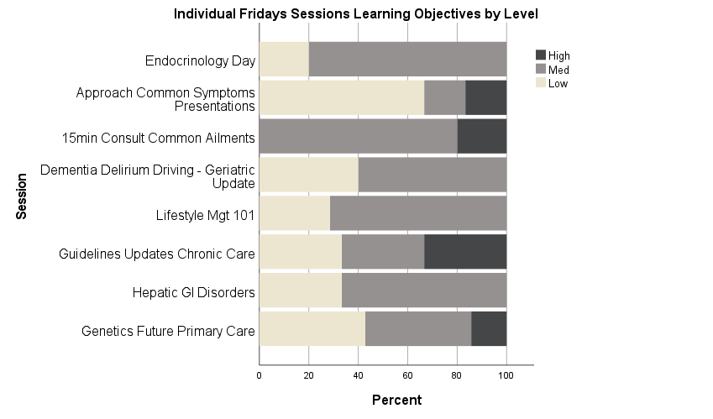

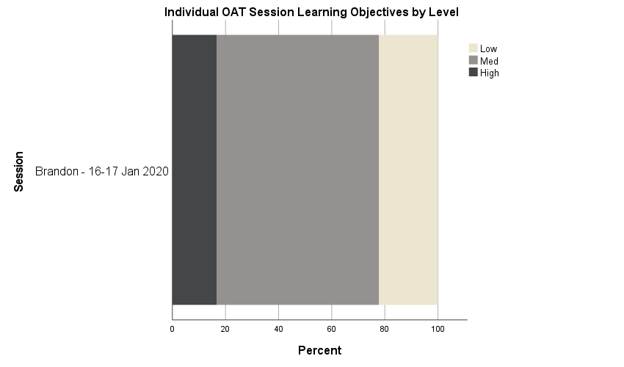For the selected OAT session, the learning objectives are distributed across all learning objective levels.

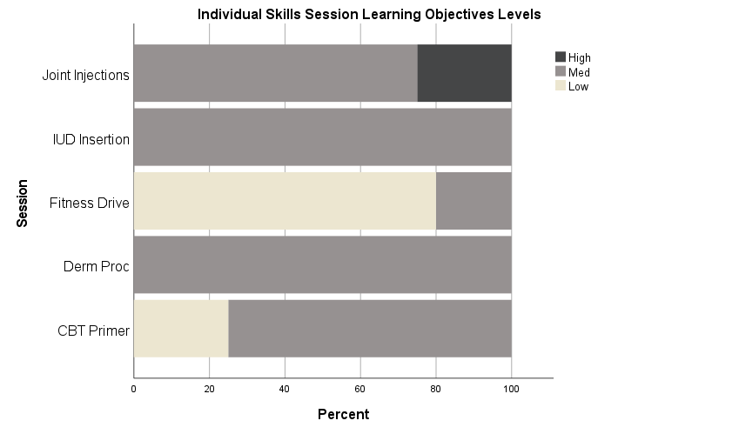For the Skills Sessions, the individual sessions varied in how the learning objectives were distributed across the learning objective levels. Some sessions, such as Fitness to Drive, focused on low-level and mid—level, while IUD Insertion and Dermatology Procedures only had mid-level. Joint injections had only mid-level and high-level learning objectives. While over all of the sessions there is a distribution of learning objectives over the different learning levels, this could be improved for each specific session.

**Q: How is EDI content currently represented in LOs?**

The methods used to search the learning objectives for EDI content was based on the work done by Dr. Sophie Soklaridis who was recently funded through a SACME Seed Funding grant (2018/2019) to undertake on project on an environment scan of physician leadership programs that include concepts of diversity, gender, and race. Project members include: Elizabeth (Betty) Lin, Georgia Black, Reena Besa, Ayelet Kuper, Morag Paton, Anna MacLeod, Constance LeBlanc, Ivan Silver, and Cynthia Whitehead. A portion of this project required a scan of conference materials and events to see if there was any EDI content. To complete this, a scan of conference materials (plenaries, workshops which would include learning objectives, and keynotes) was done to see if there was any content containing specific EDI terminology. The research team selected specific terms which they felt would represent EDI content. We learnt of this approach through the SACME Manning Series this summer, where Dr. Soklaridis presented on this topic on July 15, 2021. (Available here: [Manning Summer Series Part 2 - YouTube](https://www.youtube.com/watch?v=d7q8VnZYYFk); noted sections: 35:16-36:29 – description of searching for EDI terminology, and 55:00-56:40 – follow-up question from Helen on searching for EDI terminology).

We adapted this approach to adjust the list of terms, and scanned the learning objectives for these terms: bias, equity, culture, diversity, inclusivity, intersectionality, power, metoo and us, equality. Upon reflection, we may have missed EDI content in the session. For example, the interactivity in the Q&A sections sometimes move the discussion towards EDI content, and some of the cases or examples used by the speaker in a session may incorporate EDI content, yet this may not be reflected in the learning objectives. As such, this method was a helpful beginning to see how we could assess our learning objectives for EDI content, however, further work must be done to see how we could assess events for EDI content in a resource-effective manner. For example, we did consider reviewing all slides from events contained within the scope of this IQR project, however our office is not staffed at the level to complete such a task.

As described, we reviewed the learning objectives by keywords identified to represent EDI content. We found that in OAT some learning objectives address inclusivity (indigenous populations, prenatal patients) however specific terms are not overtly used in the learning objectives. Skills had no use of EDI language utilized in this program. In Fridays sessions, most objectives did not present EDI content in the learning objectives.

**Q: Was the curriculum mapping tool used?**

We were surprised to find that the mapping tool was not consistently used. While we all agree and see it as a valuable tool, it has been a struggle to incorporate it into our planning session, especially with Skills. For Fridays, the mapping tool was somewhat used. OAT did not use a formal mapping tool at all. Recommendations on how to encourage use are brought forward in the following ACT section.

**In summary**, we found that we are compliant with Standard 2.2, however there are some areas which could be strengthened. For example, some of our processes around ensuring quality of learning objectives happen informally between the SPC and CPD Medicine Office. We believe that this is a reflection of a collaborative culture, rather than a reflection of work not being done. However, going forward, we see the value of documenting our processes, even the ones which have been perceived as conversational. Through the process of documenting these processes, we believe that we will be able to focus on some finer details which we may have missed when our processes were undocumented, and more conversational and informal. We also found that we have an absence of EDI and anti-oppressive content highlighted within the learning objectives. While it is possible that this content did exist in the events, this could be highlighted in the learning objectives. In addition, we will consider how we will expand our needs assessment processes and practices to ensure that this content will be more visible.

## ACT Section of PDSA

This section will provide a list of identified gaps, with recommendations on how to move forward and address the gaps.

### Gap #1: Curriculum Mapping Tool Inconsistently Used.

The curriculum mapping tool was used inconsistently. While it was intended that this tool provide a foundation to the conversations on designing an educational event, sometimes the content for this tool was derived differently and put into this tool later. Thus, it is seen as an administrative artifact outside of the day-to-day work. The tool is seen as a consolidation of efforts in gathering information on how needs assessment directly relates to the derivation of learning objectives at the program and session level, selecting educational formation, ensuring interactivity is in planning, and that a breadth of CanMEDs roles are covered; but it is not yet the initial go-to document for this work. It is important that this shift to be embedded into day-to-day work, as maintaining this work in multiple other documents is inefficient. Furthermore, as the CPD Office continues to work remotely during the COVID-19 pandemic, it is important to ensure consolidation and accessible archiving of documents, retaining organizational knowledge, and succession planning, and consistent use of the curriculum mapping tool on a shared network will help to meet this need.

When reflecting on how to address this gap, there are some parallels which can be drawn to another innovation within the CPD Medicine Office. The CPD Medicine Office recently development a new online application for accreditation/certification purposes. The online application is not only an online application; it is also an educational tool, as it links to resources on how SPCs can write quality learning objectives in a health professions education context. This online application is perceived as easy-to-use, and it is worth considering how we can transfer success of this online application tool to the curriculum mapping tool, as the curriculum mapping tool could benefit in user friendliness.

***Building on strengths within the CPD Medicine Office to address this gap, it is recommended to develop a user-friendly curriculum mapping tool in Cognito Forms (similar to the online application, this is a custom interface for collecting data through an easy-to-use online form builder) that incorporates an EDI lens in creating actionable learning objectives.***

### Gap #2: Absence of EDI content in Learning Objectives

While searching for terms to assess if EDI content was used is a practice used by other CPD Canadian colleagues, this is still a very rudimentary approach to see if EDI is present in educational events. Furthermore, this is at an outer assessment level, and the connection to informing future events is rather loose.

Addressing this gap can be informed by balancing the distribution of CanMEDs roles. For example, given the topic and scope of content that was presented at the Skills workshops, it was expected to have an emphasis on Medical Expert role; however, depending on the nature of the skill session there could be an opportunity to expand or explore other CanMEDs roles. By increasing the social accountability lens, our office may be able to suggest expanding the learning objectives to cover content which would then reflect the Health Advocate role or Communicator role, *in addition* to the Medical Expert role, as it relates to the topic of the Skills workshop. Although there is evidence for forms of non-biomedical knowledge which underpin physician competencies contained within CanMEDs roles (Kuper et al., 2017), more work needs to be done to ensure that EDI is integrated into medical education as the presence of a broad range of CanMEDs roles is insufficient to ensure that EDI principles are addressed (Ing, 2021). That is, while it is important to ensure a distribution of learning objectives across CanMEDs roles, it is also important to ensure other measures are being used to integrate EDI principles into CPD, such as conducting climate surveys on EDI, incorporating EDI principles into clinical discussions, and promoting research in EDI (Ing, 2021). To inform these measures at a local level, we are currently working on a paper, *Using Theory to Situate and Develop EDI Initiatives within CPD,* recently presented at NAC 2021, and we are beginning to look at operationalizing climate surveys. We hope that in the future, measuring how we have embedded EDI principles within CPD will be more than a frequency search for specific terms, or a preferred distribution of learning objectives over CanMEDs roles.

The programs all drew on needs assessment data, which had numerous data sources. In addition to asking past and present participants attending our events topics they would like to see, we also ask clinicians what their peers would benefit from learning, we consult with stakeholders (regulatory bodies, patient safety institutes, etc.) and review literature. It is possible that we may need to review the questions asked in our needs assessment to ensure that we are not unintentionally limiting EDI topics in how we ask, and who we ask.

***It is recommended to represent all CanMEDs roles across learning objectives, which aligns with CACME Standard 2.3.***

***It is recommended to explore and expand further opportunities to incorporate EDI content into CPD educational programming.***

***It is recommended to review the Needs Assessment process to ensure that we are capturing fulsome data, responsive to practice needs, which includes specific inquiry into needed EDI content.***

***It is recommended to continue to be active and engaged members of various committees within the RFHS, such as the EDI Community of Practice Committee, and the Social Accountability Committee.***

### Gap #3: Processes need to be formalized

Names of processes to be developed and/or further documented:

* Connecting Needs Assessment to Educational Event Design
  + This happens already through the curriculum planning tool, but it is not explicitly described and documented for each event.
* Ensure distribution of learning levels and CanMEDs Roles
  + This does not currently happen for levels of learning.
  + This happens for CanMEDs roles, but isn’t documented. We have been doing it, but it has been unstructured. We need to do this in a more structured way. Given the topic and scope of content presented at some workshops, it is expected to have an emphasis on Medical Expert role; however, there could be an opportunity to expand or explore other CanMEDs roles. One example is that by increasing the social accountability lens, our office may be able to suggest how to expand the learning objectives to cover content which would then reflect the Health Advocate role or Communicator role, in addition to the Medical Expert role, as it relates to the topic of the workshop.
  + At times, the development of learning objectives is iterative between the SPC and the CPD office to ensure that they are learner-centred, etc. In addition to the dialogue that ensures the learning objectives are learner-centred, we will also incorporate dialogue to look at the distribution of learning objectives over lo-med-hi.
* Communicate Learning Objectives to Participants
  + This happens already, documentation should be updated.
* Needs Assessment Process
  + This happens already, but it is not documented.
  + Needs to be reviewed for inclusivity and anti-oppressive practices.

***It is recommended to develop these processes in a collaborative manner, through the Planning & Priorities Committee within the CPD Medicine Office.***

***It is recommended that the CPD Medicine Program engage in faculty development that supports SPC’s in supporting diverse representation, cultural awareness and addressing implicit bias.***

## Recommendations for subsequent PDSA cycle

At the time of writing this document, we were conscious of ensuring that the document reached our external reviewers within the identified project timeframe of September-October. Thus, while we desired to expand our ACT section to include more than discussing recommendations emerging from data collection and analysis thus far, we intentionally concluded the ACT section at this stage so that this work would benefit from reflection and collaboration. While the process for submitting to the external reviewer continues, our work the next PDSA based on these recommendations continues.

When we meet with the externals reviewers to discuss this first PDSA cycle, we plan to provide an update to the reviewers on our progress to demonstrate our commitment to a culture of ongoing continuous quality improvement by beginning to work through another PDSA cycle. This next PDSA cycle will focus on following-through all of the identified recommendations over the 2021/2022 academic year.

There will be multiple opportunities within the CPD Medicine Program to appraise the progress of our IQR recommendations. The CPD Medicine Program has recently approved its 2021-2026 strategic plan, of which EDI activities will be operationalized to align with the IQR recommendations. Operational planning meetings occur every eight weeks and an annual report is provided to the CPD Advisory Committee. Specific deliverables such as: modifications of the curriculum planning tool; revision of the needs assessments through an EDI lens; and building EDI faculty development resources shall be captured in Planning and Priority meetings and then reported through the operational plan. Monitoring of the trajectory of the implementation of EDI centric learning objectives, EDI session content, and EDI positive evaluative outcomes are addressed in session debriefing meetings and subsequently shared with SPC chairs for session specific quality improvement. We also see potential to present some of this work in an academic and peer-reviewed manner.

# References

Brown, A., et al. (2020). "A Tale of Four Programs: How Residents Learn About Quality Improvement during Postgraduate Medical Education at the University of Calgary." Teach Learn Med: 1-17.

Ing, E. (2021). Equity, diversity and inclusion and the CanMEDS framework. *Canadian Medical Education Journal*. <https://doi.org/10.36834/cmej.72988>

Kuper, A., Veinot, P., Leavitt, J., Levitt, S., Li, A., Goguen, J., Schreiber, M., Richardson, L., & Whitehead, C. R. (2017). Epistemology, culture, justice and power: non‐bioscientific knowledge for medical training. *Medical Education*, *51*(2), 158–173. <https://doi.org/10.1111/medu.13115>

Taylor, M. J., et al. (2014). "Systematic review of the application of the plan–do–study–act method to improve quality in healthcare." BMJ Quality & Safety **23**(4): 290-298.

# Appendix A – IQR Guide

[IQR Guide](https://www.cpd-umanitoba.com/wp-content/uploads/2021/09/Appendix-A-CACME-IQR-Quick_Guide.pdf)

# Appendix B – External Reviewer Guide

[External Reviewer Guide](https://www.cognitoforms.com/UniversityOfManitoba4/QIProjectOnlineReviewerFeedbackReport)

# Appendix C – RFHS Strategic Framework

[RFHS Strategic Framework](https://www.cpd-umanitoba.com/wp-content/uploads/2021/09/Appendix-C-RFHS-Strategic-Framework.pdf)

# Appendix D – Resources for Writing Learning Objectives

[Resources for Writing Learning Objectives](https://www.cpd-umanitoba.com/wp-content/uploads/2021/09/Appendix-D-Learning-Objectives.pdf)

# Appendix E – Curriculum Planning Tool (Past and Current)

[Curriculum Planning Tool](https://www.cpd-umanitoba.com/wp-content/uploads/2021/09/Appendix-E-Curriculum-Planning-Tool.pdf)

# Appendix F – Disruption of All Forms of Racism Policy

[Disruption of All Forms of Racism Policy](https://www.cpd-umanitoba.com/wp-content/uploads/2021/09/Appendix-F-Disruption-of-all-Forms-of-Racism-Policy.pdf)

# Appendix G – Blank Rubric (For Internal Use in the IQR Project)

**Name of Program: _________________________________**

**Date of Program: __________________________________**

|  |  |  |  |  |
| --- | --- | --- | --- | --- |
| **Item** | **Partial Compliance** | **Compliance** | **Score and Comments** | |
| The learning objectives were informed by the needs assessment results as described in Standard 2.1 | The CPD provider is unable to demonstrate how identified needs are used to develop overall and session-specific learning objectives. | The CPD provider organization demonstrates how identified needs are used to create overall and session-specific learning objectives that are written from the learner’s perspective. |  | |
| All learning objectives were written from the learner’s perspective. | Session objectives are seldom or not written from a learner's perspective. | Session objectives are written from a leaner's perspective. |  | |
| All learning objectives were consistent with the educational format. | Learning objectives were consistent with the educational format some of the time. | Learning objectives were consistent with the educational format most of the time. |  | |
| All learning objectives were provided to learners prior to the learning activity, preferably at the time of registration. | The CPD provider organization uses identified needs to develop overall and session-specific learning objectives; that are either not written from the learner’s perspective, consistent with the educational format or provided prior to the activity. | The CPD provider organization demonstrates how identified needs are used to create overall and session-specific learning objectives that are written from the learner’s perspective, consistent with the chosen educational format and provided prior to the activity for review by potential participants. |  | |
| Learning objectives are distributed across the CanMEDS roles. | The learning objectives focus mostly on the Medical Expert role. | The learning objectives are distributed across the CanMEDS Physician Competency Framework. |  | |
| **Item** | **Requires attention** | **Status Quo** | **Excellence** | **Score and Comments** |
| Learning objectives are distributed across different levels of learning. | The learning objectives are mostly at a lower level (Ideas of ICE, Start of SEE, Knowledge/Comprehension of Bloom’s). | The learning objectives are mostly at a lower level, with some at a mid level (up to Connections of ICE, up to Extend of SEE, up to Application/Analysis of Bloom’s). | The learning objectives span across all levels (up to Extensions of ICE, up to Enhance of SEE, Evaluate/Create of Bloom’s). |  |
| Learning objectives uphold the tenants of local EDI policies. | EDI content was not present in the learning objectives.  Terms: bias, equity, culture, diversity, inclusivity, intersectionality, power, metoo and us, equality | EDI content was present in some of the learning objectives; inclusivity and anti-oppressive language is used.  Terms: bias, equity, culture, diversity, inclusivity, intersectionality, power, metoo and us, equality | EDI content was present in most of the learning objectives; inclusivity and anti-oppressive language is used.  Terms: bias, equity, culture, diversity, inclusivity, intersectionality, power, metoo and us, equality |  |
| Mapping tool was used, and facilitated development of learner objectives. | Mapping tool was not used and/or mapping tool was not helpful. | Mapping tool was somewhat used, and was somewhat helpful. | Mapping tool was consistently used, and strongly facilitated development of excellent learning objectives. |  |

# Appendix H – Rubric for Fridays

**Name of Program: Fridays at the University**

**Date of Program: 2020/2021 Academic Year**

|  |  |  |  |  |
| --- | --- | --- | --- | --- |
| **Item** | **Partial Compliance** | **Compliance** | **Score and Comments** | |
| The learning objectives were informed by the needs assessment results as described in Standard 2.1 | The CPD provider is unable to demonstrate how identified needs are used to develop overall and session-specific learning objectives. | The CPD provider organization demonstrates how identified needs are used to create overall and session-specific learning objectives. | Compliance- most sessions can be mapped to needs assessments that are available through survey, needs expressed by planning committee members, or topic experts in the community. | |
| All learning objectives were written from the learner’s perspective. | Session objectives are seldom or not written from a learner's perspective. | Session objectives are written from a leaner's perspective. | Compliance?- Most learning objectives are written from a learner’s perspective using actionable verbs. | |
| All learning objectives were consistent with the educational format. | Learning objectives were consistent with the educational format some of the time. | Learning objectives were consistent with the educational format most of the time. | Compliance- All learning objectives are consistent with the educational format. | |
| All learning objectives were provided to learners prior to the learning activity, preferably at the time of registration. | The CPD provider organization uses identified needs to develop overall and session-specific learning objectives; that are either not written from the learner’s perspective, consistent with the educational format or provided prior to the activity. | The CPD provider organization demonstrates how identified needs are used to create overall and session-specific learning objectives that are written from the learner’s perspective, consistent with the chosen educational format and provided prior to the activity for review by potential participants. | * Registration page * Agenda (emailed to participants prior to the event) * Evaluation form | |
| Learning objectives are distributed across the CanMEDS roles. | The learning objectives focus mostly on the Medical Expert role. | The learning objectives are distributed across the CanMEDS Physician Competency Framework. | Compliance- Most sessions address multiple CanMEDs roles, however Medical Expert is still the predominant role. Women’s Health Day not tagged for roles- however objectives were across multiple roles. Discrepancies exist over interpretation of correct roles however.   |  |  |  |  |  |  |  |  |  | | --- | --- | --- | --- | --- | --- | --- | --- | --- | | **Event** | **Presence** | **Count by CanMEDs Role** | | | | | | | | Medical Expert | Communicator | Collaborator | Leader | Health Advocate | Scholar | Professional | | **Fridays** | Yes | 40 | 22 | 20 | 0 | 8 | 16 | 1 | | No | 6 | 24 | 26 | 46 | 38 | 30 | 45 |   Recommendation: As discrepancies exist in interpretation, it is recommended to have ongoing iterative dialogue between the SPC and the CPD office to ensure clarity of CanMEDs roles to be expressed in each of the learning objective. It was the intent of the Curriculum Planning Framework to provide a foundation for this dialogue, however, this has bot been consistently used. It is recommended to use this framework consistently for all developed programming, and recommend the framework for our external programmers. | |
| **Item** | **Requires attention** | **Status Quo** | **Excellence** | **Score and Comments** |
| Learning objectives are distributed across different levels of learning. | The learning objectives are mostly at a lower level (Ideas of ICE, Start of SEE, Knowledge/Comprehension of Bloom’s). | The learning objectives are mostly at a lower level, with some at a mid level (up to Connections of ICE, up to Extend of SEE, up to Application/Analysis of Bloom’s). | The learning objectives span across all levels (up to Extensions of ICE, up to Enhance of SEE, Evaluate/Create of Bloom’s). | Compliance- Most sessions address multiple CanMEDs roles, however Medical Expert is still the predominant role. Women’s Health Day not tagged for roles- however objectives were across multiple roles. Discrepancies exist over interpretation of correct roles however.  For the Fridays at the University sessions, 4 sessions spanned all levels, and 4 sessions spanned only low-level to mid-level learning objective levels. While over all of the sessions there is a distribution of learning objectives over the different learning levels, this could be improved for each specific session. |
| Learning objectives uphold the tenants of local EDI policies. | EDI content was not present in the learning objectives.  Terms: bias, equity, culture, diversity, inclusivity, intersectionality, power, metoo and us, equality | EDI content was present in some of the learning objectives; inclusivity and anti-oppressive language is used.  Terms: bias, equity, culture, diversity, inclusivity, intersectionality, power, metoo and us, equality | EDI content was present in most of the learning objectives; inclusivity and anti-oppressive language is used.  Terms: bias, equity, culture, diversity, inclusivity, intersectionality, power, metoo and us, equality | Requires Attention  Most objectives did not present EDI contect in the learning objectives. |
| Mapping tool was used, and facilitated development of learner objectives. | Mapping tool was not used and/or mapping tool was not helpful. | Mapping tool was somewhat used, and was somewhat helpful. | Mapping tool was consistently used, and strongly facilitated development of excellent learning objectives. | Status Quo- mapping tool was somewhat used |

# Appendix I – Rubric for Skills

**Name of Program: Skills Workshops**

**Date of Program: 2020/2021 Academic Year**

|  |  |  |  |  |
| --- | --- | --- | --- | --- |
| **Item** | **Partial Compliance** | **Compliance** | **Score and Comments** | |
| The learning objectives were informed by the needs assessment results as described in Standard 2.1 | The CPD provider is unable to demonstrate how identified needs are used to develop overall and session-specific learning objectives. | The CPD provider organization demonstrates how identified needs are used to create overall and session-specific learning objectives that are written from the learner’s perspective. | Compliance- Needs assessments are informed at multiple levels including pre activity needs informed by actual participants, CPD survey data, previous workshop evaluation data, post survey workshop data. | |
| All learning objectives were written from the learner’s perspective. | Session objectives are seldom or not written from a learner's perspective. | Session objectives are written from a learner's perspective. | Compliance- Most objectives are written from a learner’s perspective. Actionable objectives that require learners to demonstrate the newly acquired skill, explain indications for procedures and explain the best evidence are utilized. | |
| All learning objectives were consistent with the educational format. | Learning objectives were consistent with the educational format some of the time. | Learning objectives were consistent with the educational format most of the time. | Compliance- Educational format aligns with learning objectives in that small group sessions encourage discussions on best practices and largely focus on demonstration of the newly acquired skill. | |
| All learning objectives were provided to learners prior to the learning activity, preferably at the time of registration. | The CPD provider organization uses identified needs to develop overall and session-specific learning objectives; that are either not written from the learner’s perspective, consistent with the educational format or provided prior to the activity. | The CPD provider organization demonstrates how identified needs are used to create overall and session-specific learning objectives that are written from the learner’s perspective, consistent with the chosen educational format and provided prior to the activity for review by potential participants. | * Registration page * Agendas (emailed to participants prior to event) | |
| Learning objectives are distributed across the CanMEDS roles. | The learning objectives focus mostly on the Medical Expert role. | The learning objectives are distributed across the CanMEDS Physician Competency Framework. | While the majority of learning objectives were representative of the Medical Expert role, Communicator, and Scholar also appeared rather frequently. Roles such as Collaborator, Health Advocate, and Professional appeared less frequently, and Leader did not appear at all. Given the topic and scope of content that was presented at these Skills workshops, it is expected to have an emphasis on Medical Expert role; however, depending on the nature of the skill session there could be an opportunity to expand or explore other CanMEDs roles. One example is that by increasing the social accountability lense, our office may be able to suggest expanding the learning objectives to cover content which would then reflect the Health Advocate role or Communicator role, in addition to the Medical Expert role, as it relates to the topic of the Skills workshop.   |  |  |  |  |  |  |  |  |  | | --- | --- | --- | --- | --- | --- | --- | --- | --- | | **Event** | **Presence** | **Count by CanMEDs Role** | | | | | | | | Medical Expert | Communicator | Collaborator | Leader | Health Advocate | Scholar | Professional | | **Skills** | Yes | 24 | 10 | 3 | 0 | 2 | 8 | 3 | | No | 2 | 16 | 23 | 26 | 23 | 18 | 23 | | Unsure | 0 | 0 | 0 | 0 | 1 | 0 | 0 | | |
| **Item** | **Requires attention** | **Status Quo** | **Excellence** | **Score and Comments** |
| Learning objectives are distributed across different levels of learning. | The learning objectives are mostly at a lower level (Ideas of ICE, Start of SEE, Knowledge/Comprehension of Bloom’s). | The learning objectives are mostly at a lower level, with some at a mid level (up to Connections of ICE, up to Extend of SEE, up to Application/Analysis of Bloom’s). | The learning objectives span across all levels (up to Extensions of ICE, up to Enhance of SEE, Evaluate/Create of Bloom’s). | For the Skills Sessions, the individual sessions varied in how the learning objectives were distributed across the learning objective levels. Some sessions, such as Fitness to Drive, focused on low-level and mid—level, while IUD Insertion and Dermatology Procedures only had mid-level. Joint injections had only mid-level and high-level learning objectives. While over all of the sessions there is a distribution of learning objectives over the different learning levels, this could be improved for each specific session.  The categorization of learning objects over low-med-hi is a new practice brought on by completed this IQR project. When planning educational events, the focus was on ensuring that the learning objectives defined and provided scope to the content that was to be covered. Going forward, having the extra layer of low-med-hi *in addition* to providing a structure for the content would provide an extra layer of educational quality.  Recommendation: We have been doing it, but it has been unstructured. We need to do this in a more structured way. At times, the development of learning objectives is iterative between the SPC and the CPD office to ensure that they are learner-centred, etc. In addition to the dialogue that ensures the learning objectives are learner-centred, we will also incorporate dialogue to look at the distribution of learning objectives over lo-med-hi. |
| Learning objectives uphold the tenants of local EDI policies. | EDI content was not present in the learning objectives.  Terms: bias, equity, culture, diversity, inclusivity, intersectionality, power, metoo and us, equality | EDI content was present in some of the learning objectives; inclusivity and anti-oppressive language is used.  Terms: bias, equity, culture, diversity, inclusivity, intersectionality, power, metoo and us, equality | EDI content was present in most of the learning objectives; inclusivity and anti-oppressive language is used.  Terms: bias, equity, culture, diversity, inclusivity, intersectionality, power, metoo and us, equality | Requires Attention- no use of EDI language utilized in this program. |
| Mapping tool was used, and facilitated development of learner objectives. | Mapping tool was not used and/or mapping tool was not helpful. | Mapping tool was somewhat used, and was somewhat helpful. | Mapping tool was consistently used, and strongly facilitated development of excellent learning objectives. | Requires attention- mapping tool not helpful or used in the planning of this series. |

# Appendix J – Rubric for OAT

**Name of Program: OAT**

**Date of Program: Brandon 16-17 January 2020**

|  |  |  |  |  |
| --- | --- | --- | --- | --- |
| **Item** | **Partial Compliance** | **Compliance** | **Score and Comments** | |
| The learning objectives were informed by the needs assessment results as described in Standard 2.1 | The CPD provider is unable to demonstrate how identified needs are used to develop overall and session-specific learning objectives. | The CPD provider organization demonstrates how identified needs are used to create overall and session-specific learning objectives that are written from the learner’s perspective. | Compliance- The SPC uses multiple needs assessment strategies including surveys, pre workshop needs assessments on the learners, pretest results, evaluation data from previous events, and post event survey data from previous events. | |
| All learning objectives were written from the learner’s perspective. | Session objectives are seldom or not written from a learner's perspective. | Session objectives are written from a leaner's perspective. | Compliance- all objectives use actional verbs and are written from the learner’s perspective. | |
| All learning objectives were consistent with the educational format. | Learning objectives were consistent with the educational format some of the time. | Learning objectives were consistent with the educational format most of the time. | Compliance- all learning objectives are consistent with educational format of didactic learning. Simulations using standardized patients support learning objectives that focus on communication and collaboration strategies in an interprofessional health team. | |
| All learning objectives were provided to learners prior to the learning activity, preferably at the time of registration. | The CPD provider organization uses identified needs to develop overall and session-specific learning objectives; that are either not written from the learner’s perspective, consistent with the educational format or provided prior to the activity. | The CPD provider organization demonstrates how identified needs are used to create overall and session-specific learning objectives that are written from the learner’s perspective, consistent with the chosen educational format and provided prior to the activity for review by potential participants. | * Registration page * Promo - brochure | |
| Learning objectives are distributed across the CanMEDS roles. | The learning objectives focus mostly on the Medical Expert role. | The learning objectives are distributed across the CanMEDS Physician Competency Framework. | Compliance- most objectives address multiple CanMEDS roles. 11/12 specific sessions have objectives distributed over multiple CanMEDS roles. 1/3 over all objectives meet this criteria as written.   |  |  |  |  |  |  |  |  |  | | --- | --- | --- | --- | --- | --- | --- | --- | --- | | **Event** | **Presence** | **Count by CanMEDs Role** | | | | | | | | Medical Expert | Communicator | Collaborator | Leader | Health Advocate | Scholar | Professional | | **OAT** | Yes | 19 | 5 | 13 | 3 | 7 | 2 | 1 | | No | 2 | 16 | 8 | 18 | 14 | 19 | 20 | | |
| **Item** | **Requires attention** | **Status Quo** | **Excellence** | **Score and Comments** |
| Learning objectives are distributed across different levels of learning. | The learning objectives are mostly at a lower level (Ideas of ICE, Start of SEE, Knowledge/Comprehension of Bloom’s). | The learning objectives are mostly at a lower level, with some at a mid level (up to Connections of ICE, up to Extend of SEE, up to Application/Analysis of Bloom’s). | The learning objectives span across all levels (up to Extensions of ICE, up to Enhance of SEE, Evaluate/Create of Bloom’s). | For the selected OAT session, the learning objectives are distributed across all learning objective levels.    The categorization of learning objects over low-med-hi is a new practice brought on by completed this IQR project. When planning educational events, the focus was on ensuring that the learning objectives defined and provided scope to the content that was to be covered. Going forward, having the extra layer of low-med-hi *in addition* to providing a structure for the content would provide an extra layer of educational quality.  Recommendation: We have been doing it, but it has been unstructured. We need to do this in a more structured way. At times, the development of learning objectives is iterative between the SPC and the CPD office to ensure that they are learner-centred, etc. In addition to the dialogue that ensures the learning objectives are learner-centred, we will also incorporate dialogue to look at the distribution of learning objectives over lo-med-hi. |
| Learning objectives uphold the tenants of local EDI policies. | EDI content was not present in the learning objectives.  Terms: bias, equity, culture, diversity, inclusivity, intersectionality, power, metoo and us, equality | EDI content was present in some of the learning objectives; inclusivity and anti-oppressive language is used.  Terms: bias, equity, culture, diversity, inclusivity, intersectionality, power, metoo and us, equality | EDI content was present in most of the learning objectives; inclusivity and anti-oppressive language is used.  Terms: bias, equity, culture, diversity, inclusivity, intersectionality, power, metoo and us, equality | Status Quo- some learning objectives address inclusivity (indigenous populations, prenatal patients) however specific terms are not overtly used in the learning objectives. |
| Mapping tool was used, and facilitated development of learner objectives. | Mapping tool was not used and/or mapping tool was not helpful. | Mapping tool was somewhat used, and was somewhat helpful. | Mapping tool was consistently used, and strongly facilitated development of excellent learning objectives. | Requires Attention- no formal mapping tool is used. |

# Appendix K – Needs Assessment Data

[K1 Needs Assessment Data](https://www.cpd-umanitoba.com/wp-content/uploads/2021/09/Appendix-K.1-Needs-Assessment-Data.pdf) (Needs Assessment Data)

[K2 Needs Assessment Data](https://www.cpd-umanitoba.com/wp-content/uploads/2021/09/Appendix-K.2-CPD-Needs-Assessment-2020.pdf) (CPD Needs Assessment 2020)

[K3 Needs Assessment Data](https://www.cpd-umanitoba.com/wp-content/uploads/2021/09/Appendix-K.3-Specialist-Needs-Assessment-2021.pdf) (Specialist Needs Assessment 2021)

# Appendix L – Documents for Fridays

[Documents for Fridays](https://www.cpd-umanitoba.com/wp-content/uploads/2021/09/Appendix-L-Documents-for-Fridays.pdf)

# Appendix M – Documents for Skills

[Documents for Skills](https://www.cpd-umanitoba.com/wp-content/uploads/2021/09/Appendix-M-Documents-for-Skills.pdf)

# Appendix N – Documents for OAT (Brandon Jan 16-17 Session)

[Documents for OAT](https://www.cpd-umanitoba.com/wp-content/uploads/2021/09/Appendix-N-Documents-for-OAT.pdf)

# Appendix O – EDI Theories in SPCs

[EDI Theories in SPCs](https://www.cpd-umanitoba.com/wp-content/uploads/2021/10/Appendix-O-EDI-theory-in-SPCs.pdf)